**QuantlibXL Download and Setup:**

* First of all, **don’t** download the **QuantLibXL** version on: <http://quantlib.org/quantlibxl/>
* The right version is downloadable online at this link: <https://github.com/paolomazzocchi/quantlib-old>

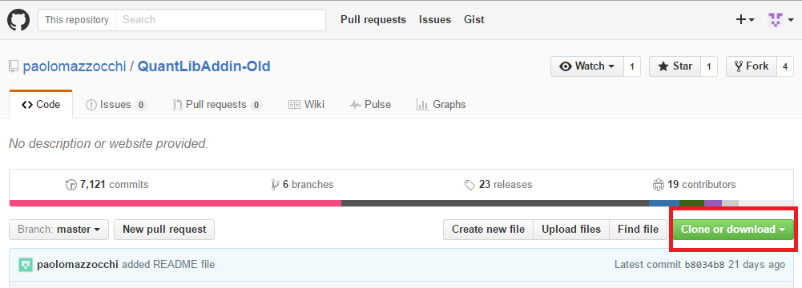

* It’s recommended to create a GitHub account

- For a GitHub Setup detailed explanation please go to: <https://github.com/NicholasBertocchi>;

- You can also find a CNTML Setup explanation (useful to setup Git).

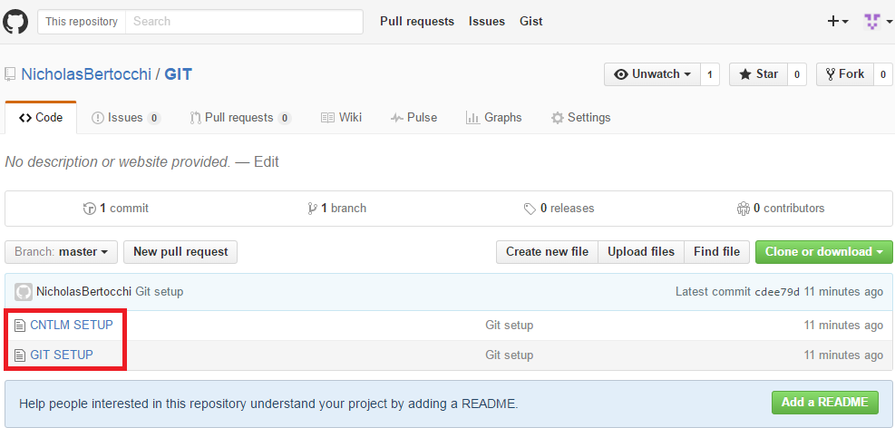

* Open QuantLibAddin-Old-master folder and follow this instructions:
* Open XL-Launcher folder;
* Go to bin 🡪 Addin 🡪 **Launcher.xla**
* Now double-click to open an empty QuantLibXL session

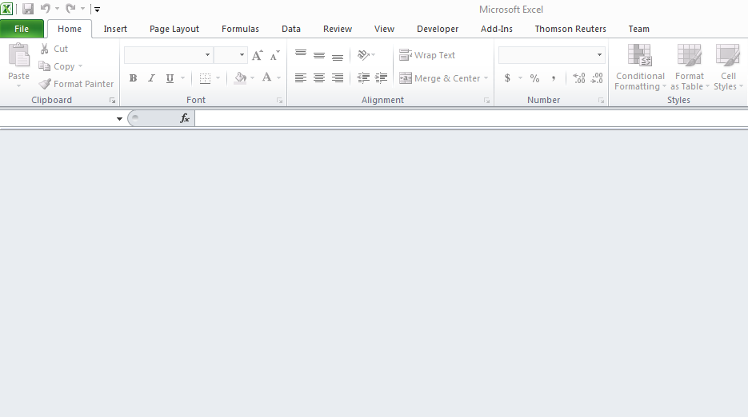

* You are ready to open **InterestRateBasics.xlsx** files

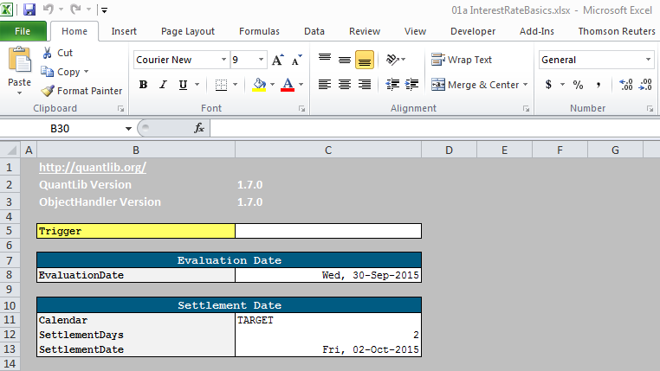

* Don’t forget to **trigger** after every settings change.